**Require to install before Training.**

Remind: Some task specific for each OS user.

+ Windows user

+ Mac user

+ Linux user

**Tools to install:**

* WSL (Windows user)
* Docker CE (Windows and Linux user)
* Docker Desktop (Mac user)
* Python – miniconda with conda-forge (All user)
* VSCode (All user)
* Postman (All user)

**(Windows user do this)**

**How to install WSL (Ubuntu) on Windows10 (2004 up) and Windows11**

If using older Windows10 2004, please following this step

<https://learn.microsoft.com/en-us/windows/wsl/install-manual>

1. Open “Power Shell” with Administrator privileges

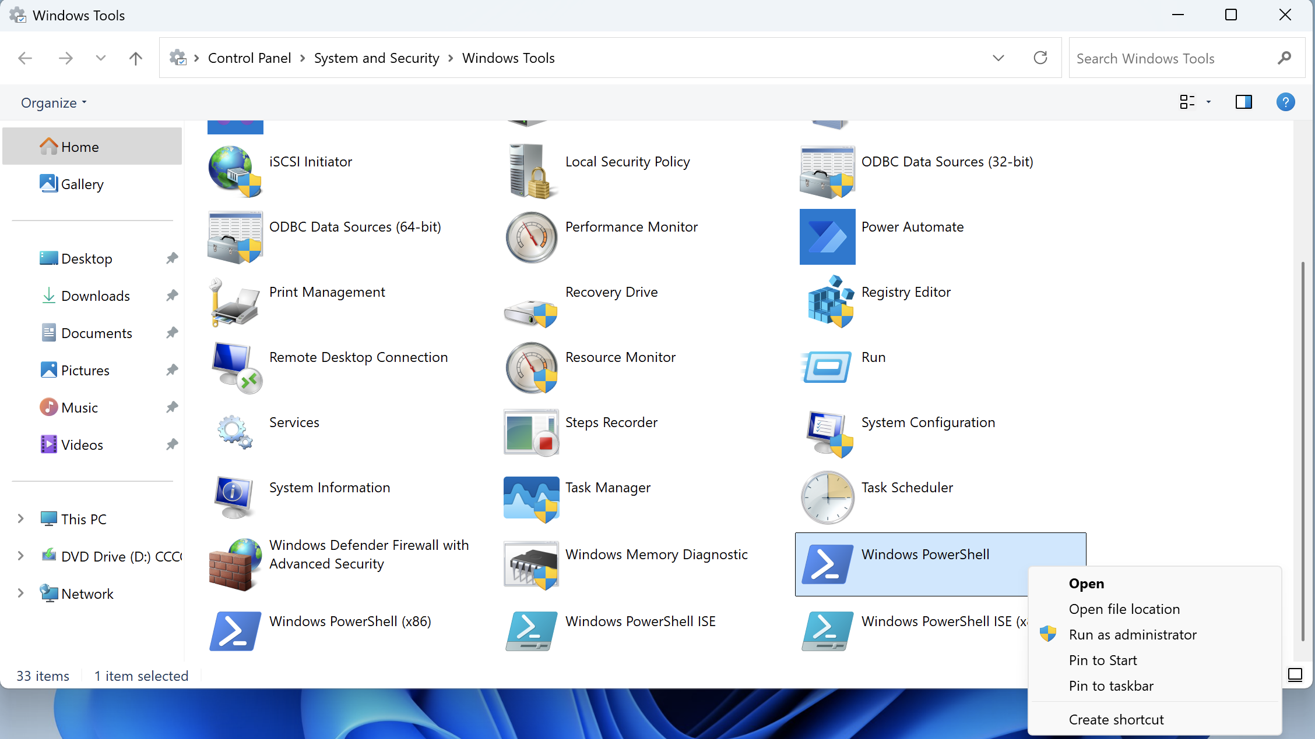

2. install WSL (Windows Sub-System Linux) by enter command

wsl --install

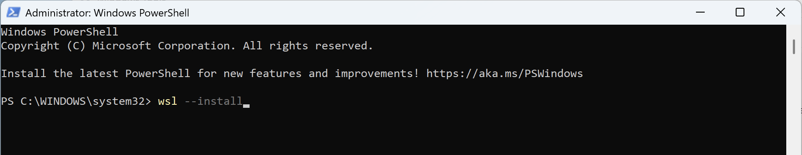

Result on successful:

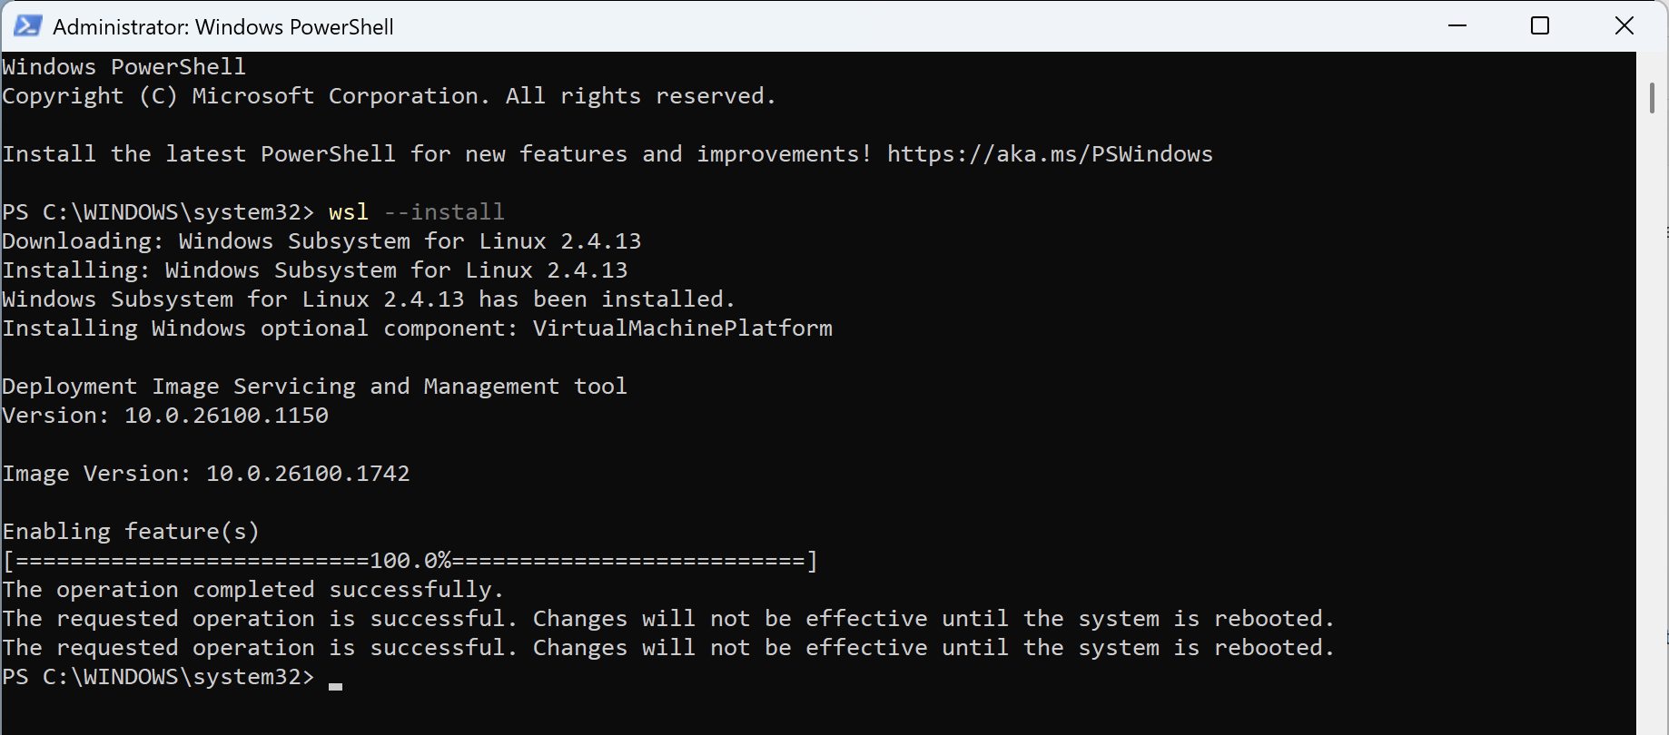

4. Reboot your computer

5. Open “Power Shell” with Administrator privileges again

6. Check current installed distribution (if any) by command

wsl --list --all

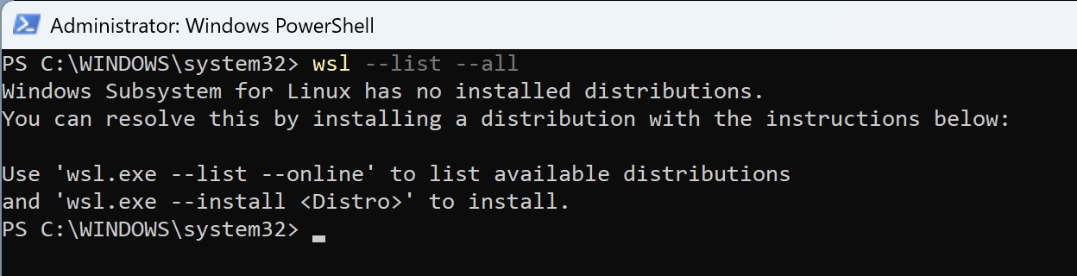

7. List of available Linux distributions available

wsl --list --online

Result:

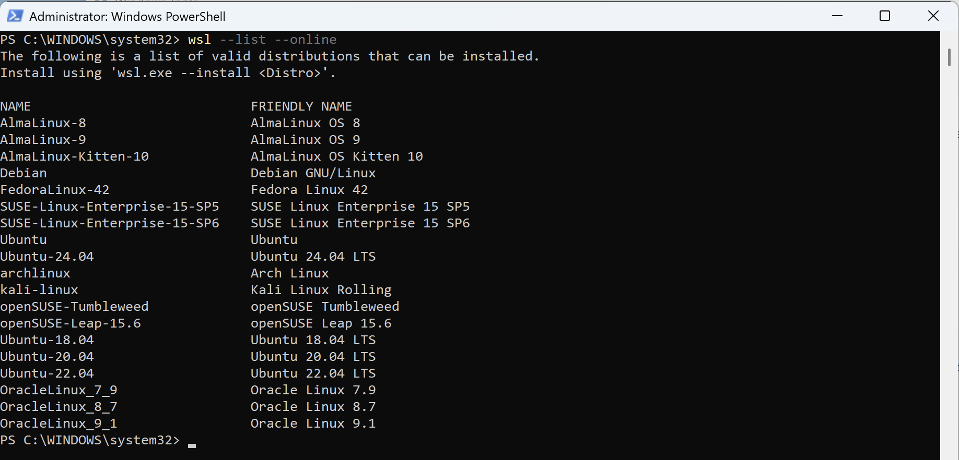

8. Install Ubuntu-24.04 on WSL

wsl --install -d Ubuntu-24.04

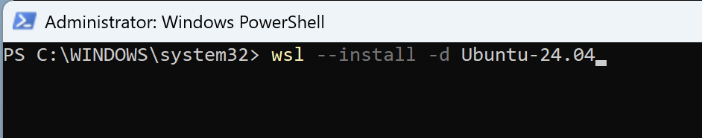

Result:

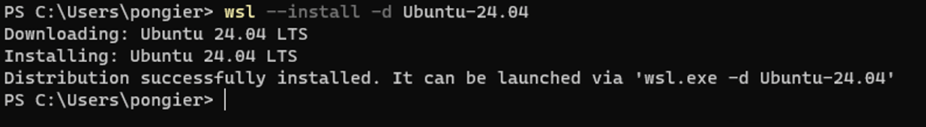

9. Start WSL console by “Start” -> “All” -> “WSL”

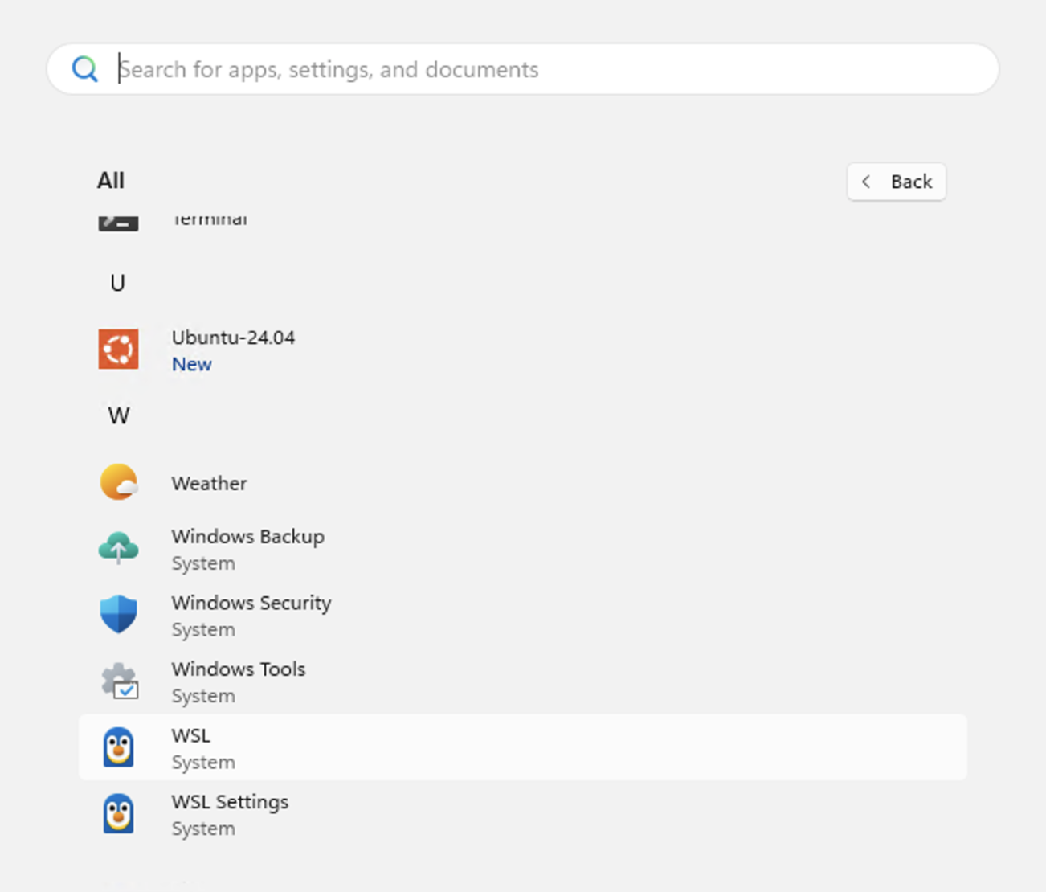

10. Initial on first use (Here we are using Ubuntu on WSL)

**Please remember, if you forget these, it very hard to re-initial**

User account: pongier

New password: Abcd@1234

Retype new password: Abcd@1234

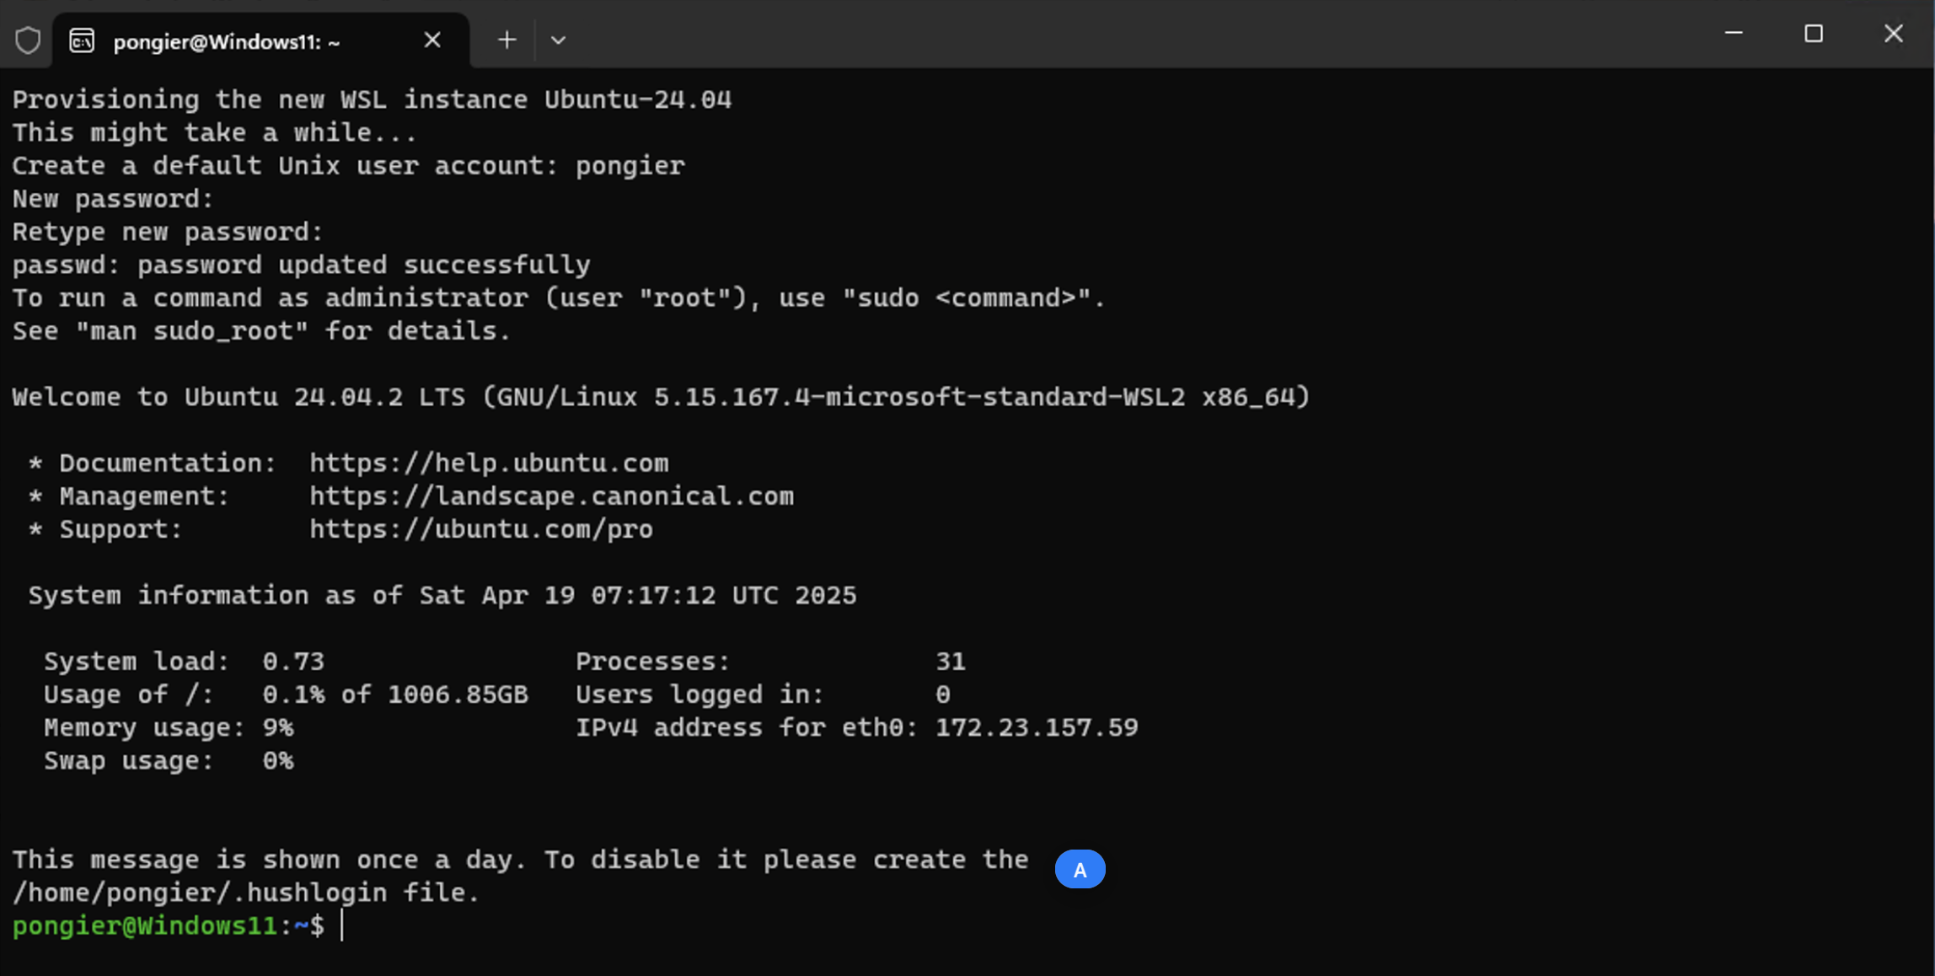

**(Windows and Linux user do this)**

**How to install Docker CE on Ubuntu (Both WSL or Native Linux) – (COntainer)**

1. Update Ubuntu apt repository

|  |
| --- |
| sudo apt update |

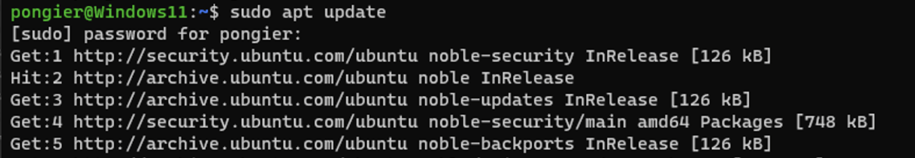

2. Update PKI

|  |
| --- |
| sudo apt-get install ca-certificates curl |

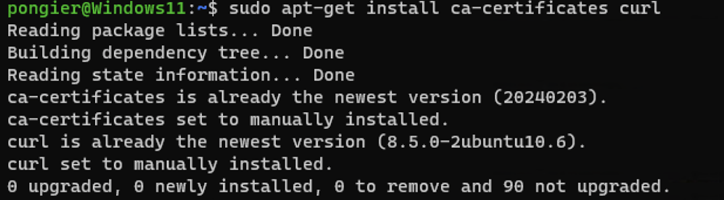

3. Initial APT Keyring

|  |
| --- |
| sudo install -m 0755 -d /etc/apt/keyrings  sudo curl -fsSL https://download.docker.com/linux/ubuntu/gpg -o /etc/apt/keyrings/docker.asc  sudo chmod a+r /etc/apt/keyrings/docker.asc |



4. Add the repository to Apt sources

|  |
| --- |
| echo \  "deb [arch=$(dpkg --print-architecture) signed-by=/etc/apt/keyrings/docker.asc] https://download.docker.com/linux/ubuntu \  $(. /etc/os-release && echo "${UBUNTU_CODENAME:-$VERSION_CODENAME}") stable" | \  sudo tee /etc/apt/sources.list.d/docker.list > /dev/null  sudo apt-get update |

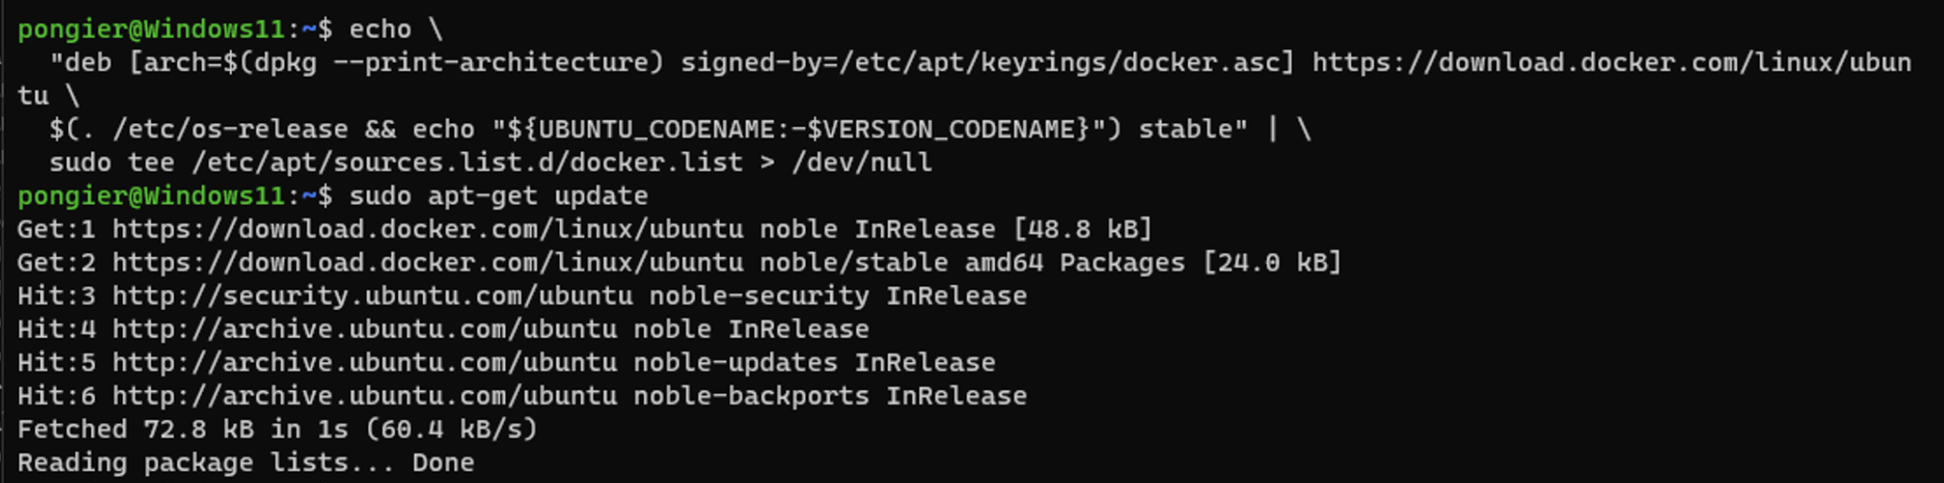

5. Install the Docker packages (Latest version)

|  |
| --- |
| sudo apt-get install docker-ce docker-ce-cli containerd.io docker-buildx-plugin docker-compose-plugin |

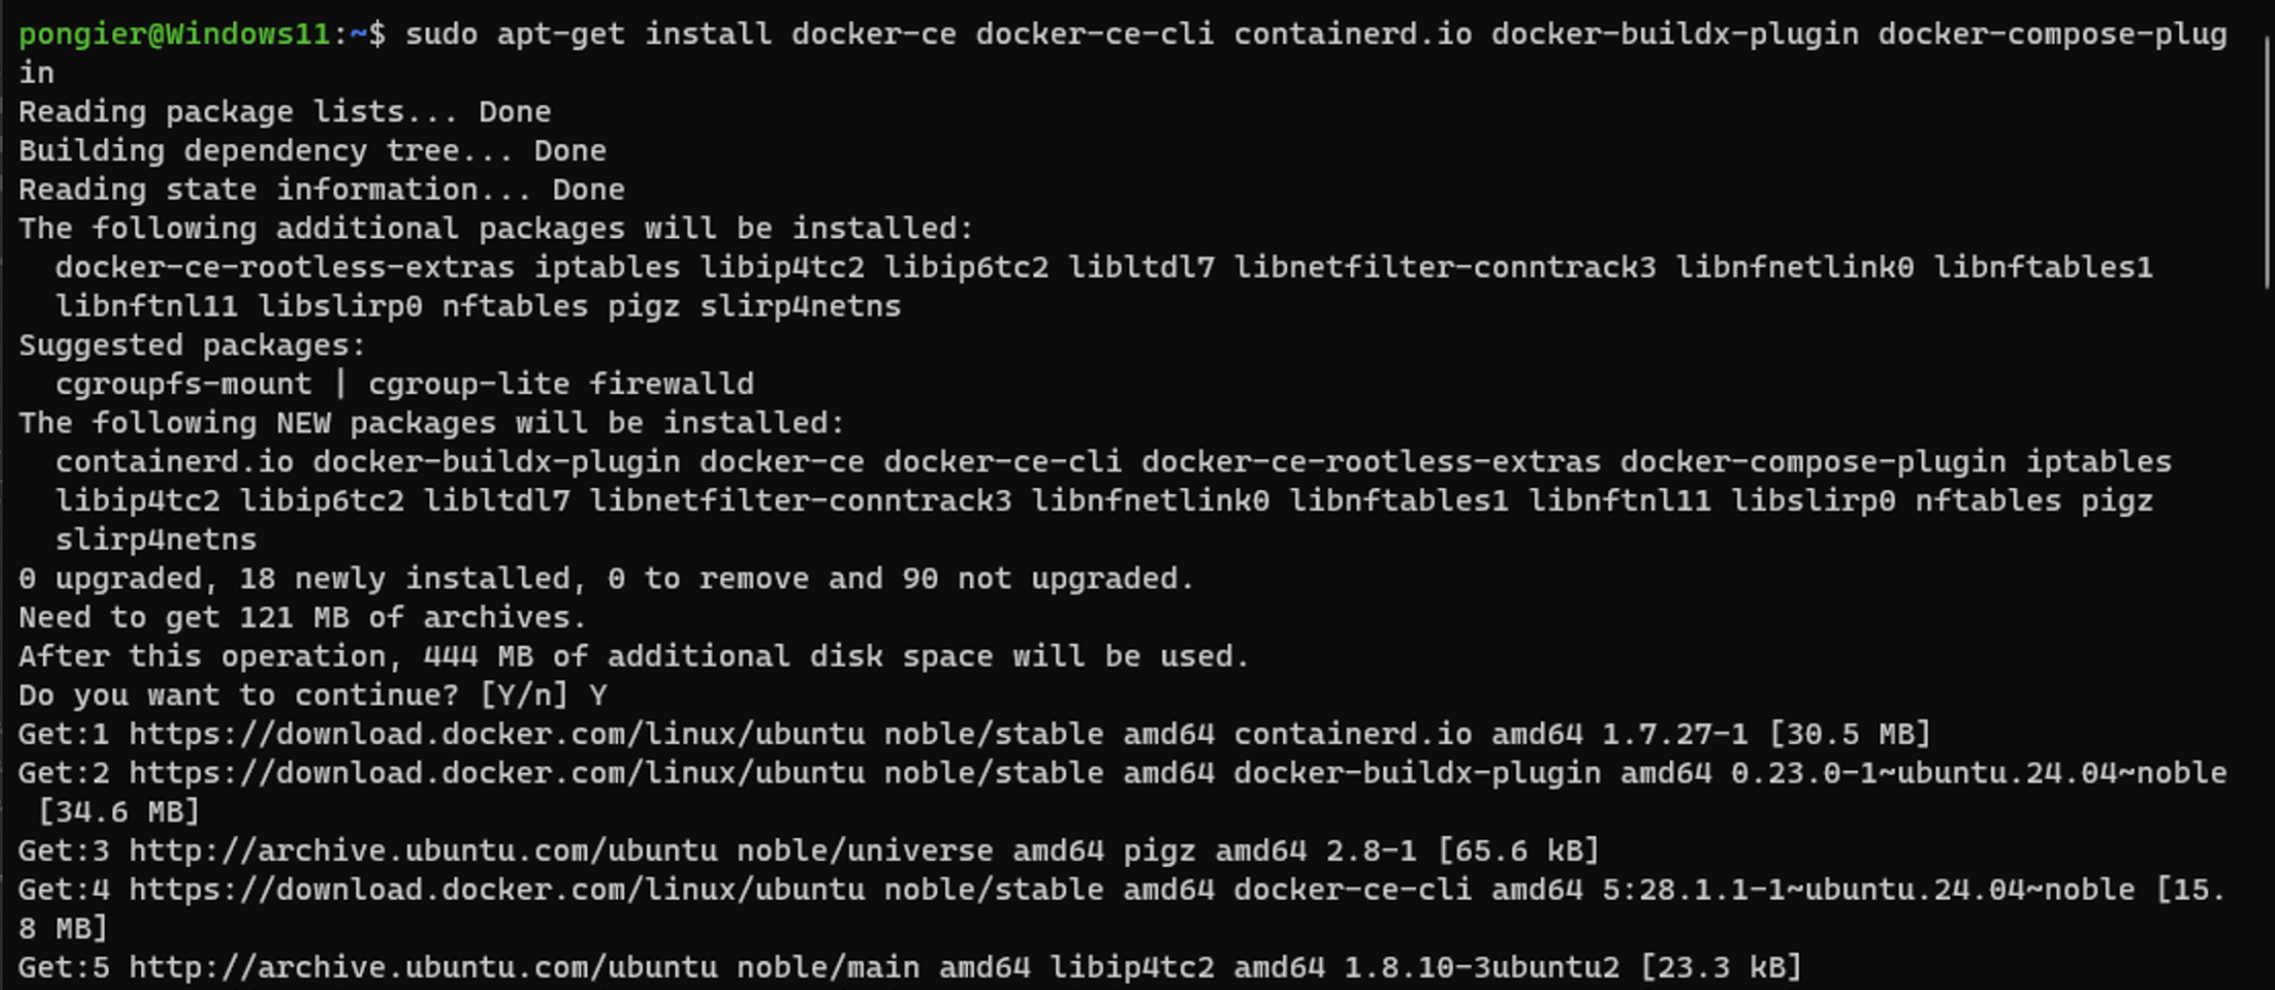

6. Test Docker first application

|  |
| --- |
| sudo docker run hello-world |

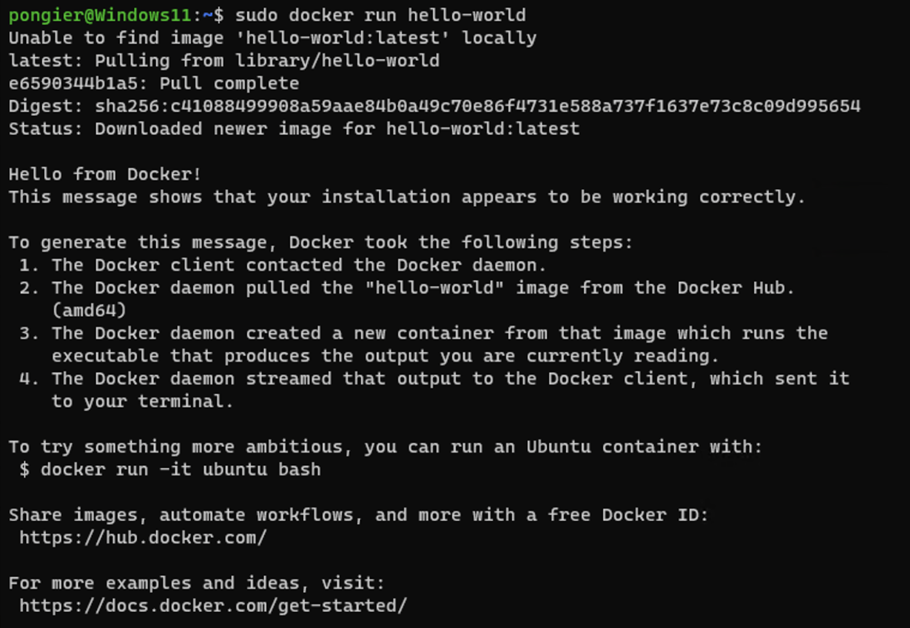

For other Linux distribution please following:

<https://docs.docker.com/engine/install/>

**(Mac user)**

**How to install Docker Desktop on MacOSX (Container)**

(License concern: Docker Desktop is free for small businesses (fewer than 250 employees AND less than $10 million in annual revenue), personal use, education, and non-commercial open source projects.)

If using Apple Silicon, For the best experience, it's recommended that you install Rosetta 2

1. Download the installer from

* Apple silicon
  + <https://desktop.docker.com/mac/main/arm64/Docker.dmg>
* Intel
  + <https://desktop.docker.com/mac/main/amd64/Docker.dmg>

2. Double-click Docker.dmg to open the installer, then drag the Docker icon to the Applications folder. By default, Docker Desktop is installed at /Applications/Docker.app.

3. Double-click Docker.app in the Applications folder to start Docker. The Docker menu displays the Docker Subscription Service Agreement.

4. Select Accept to continue.

5. From the installation, select

Use recommended settings (Requires password). This lets Docker Desktop automatically set the necessary configuration settings.

6. Select Finish.

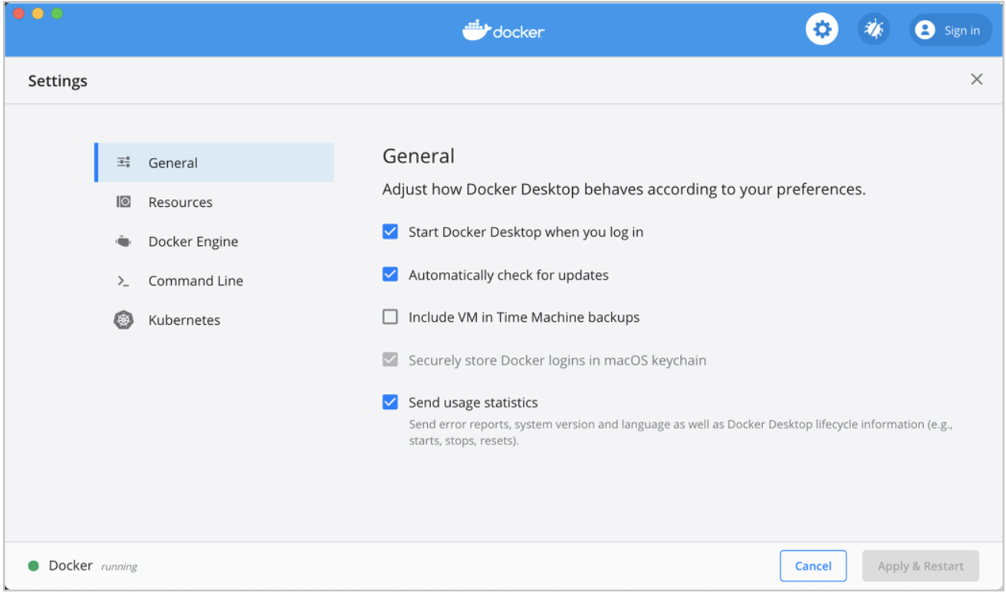

**(All user)**

**How to install Python (miniconda with conda-forge) (Programming Lang.)**

Remark:

Windows user install on WSL

Linux user install on native Linux OS

Mac user install on MacOSX

1. (Example) Download miniconda from

* Apple silicon
  + <https://repo.anaconda.com/miniconda/Miniconda3-latest-MacOSX-arm64.pkg>
* Intel
  + <https://repo.anaconda.com/miniconda/Miniconda3-latest-MacOSX-x86_64.pkg>

https://www.anaconda.com/download/success

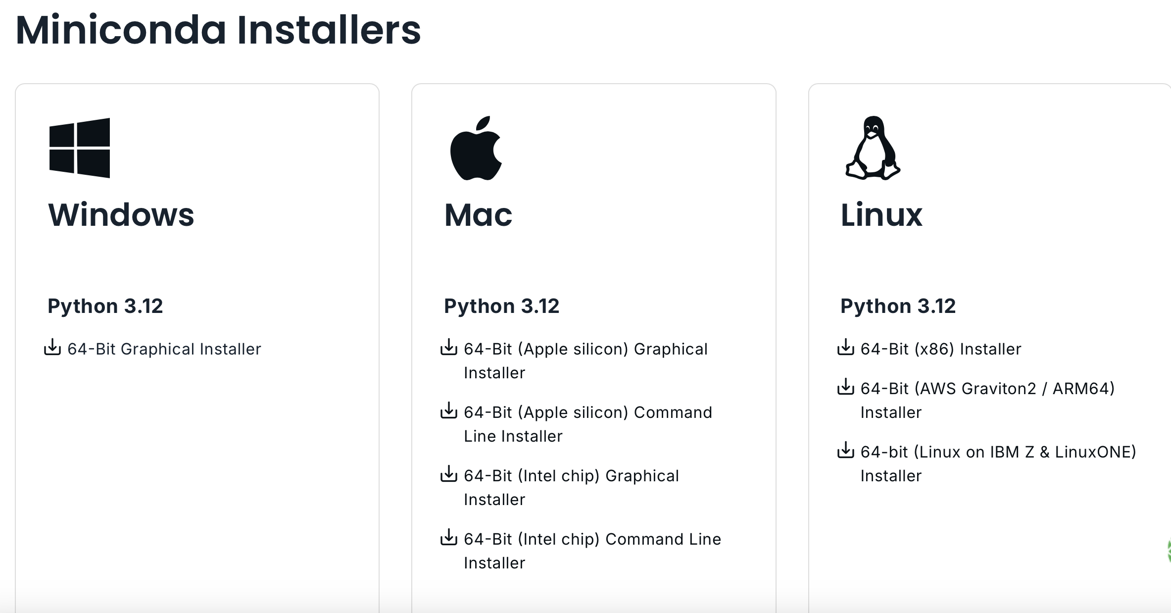

**Windows and Linux user**

**Mac user**

3. (All user) Open WSL/Terminal console

4. (All user) Create initial and install miniconda

Replace URL by your OS

* Mac Apple silicon
  + <https://repo.anaconda.com/miniconda/Miniconda3-latest-MacOSX-arm64.sh>
* Mac Intel
  + <https://repo.anaconda.com/miniconda/Miniconda3-latest-MacOSX-x86_64.sh>
* Windows/Linux
  + <https://repo.anaconda.com/miniconda/Miniconda3-latest-Linux-x86_64.sh>

|  |
| --- |
| mkdir -p ~/miniconda3  wget URL -O ~/miniconda3/miniconda.sh  bash ~/miniconda3/miniconda.sh -b -u -p ~/miniconda3 |

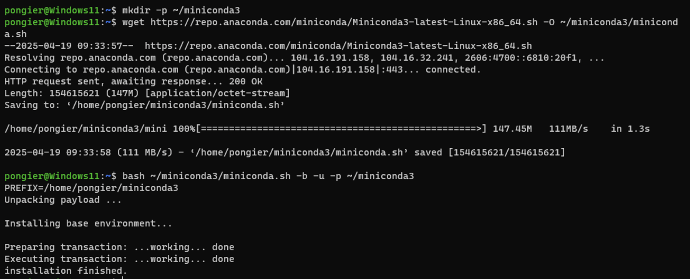

5. (All user) Activate conda sh

|  |
| --- |
| source ~/miniconda3/bin/activate |

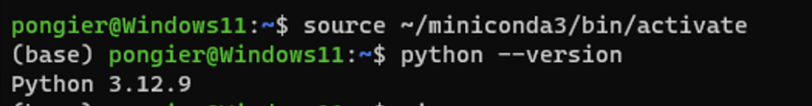

6. (All user) Setting up conda-forge

|  |
| --- |
| conda config --add channels conda-forge  conda config --set channel_priority strict |

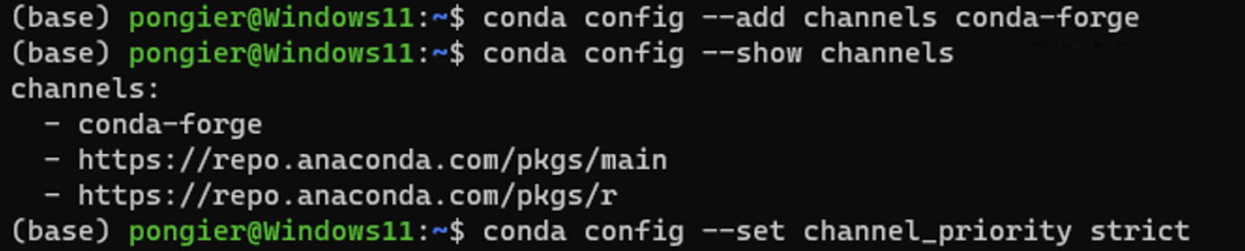

Anaconda's licensing policies have made some organizations with more than 200 employees, to pay 600USD for one license. An alternative is to use Miniconda, a lightweight version of Anaconda, in combination with the conda-forge channel.

**(All user)**

**How to install VSCode (With related extension) – (Code Development)**

VSCode Extension

* Python
* Remote Development

1. (All user) Download and Install VSCode

* <https://code.visualstudio.com/download>

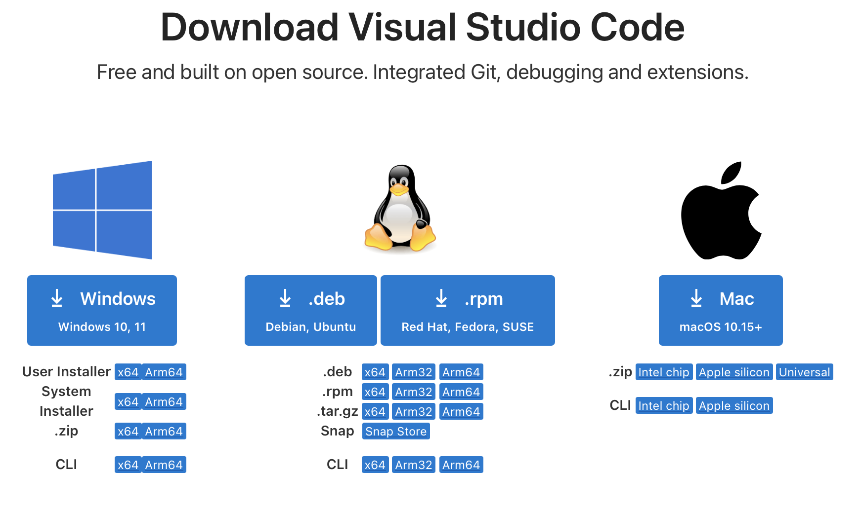

**Windows user**

**Mac user**

**Linux user**

2. Following the installation wizard

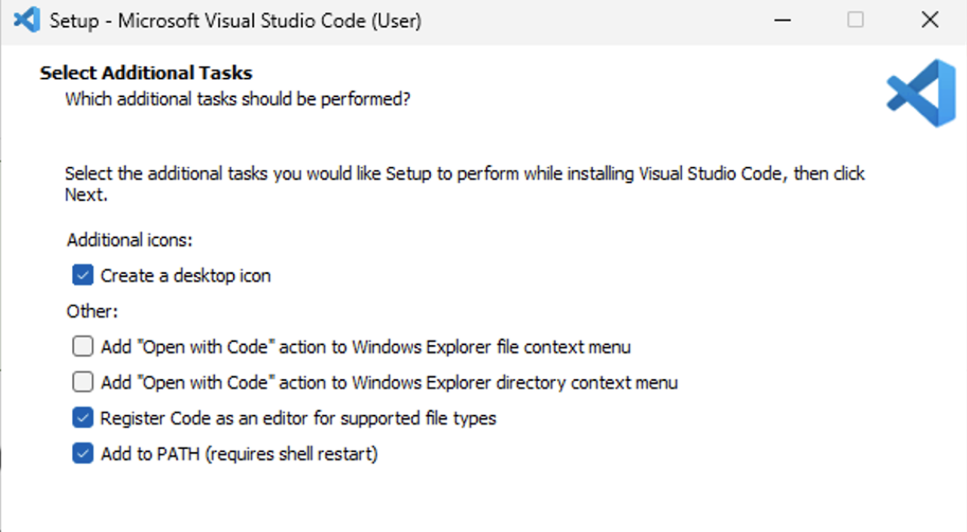

3. (All user) Install Python Extension

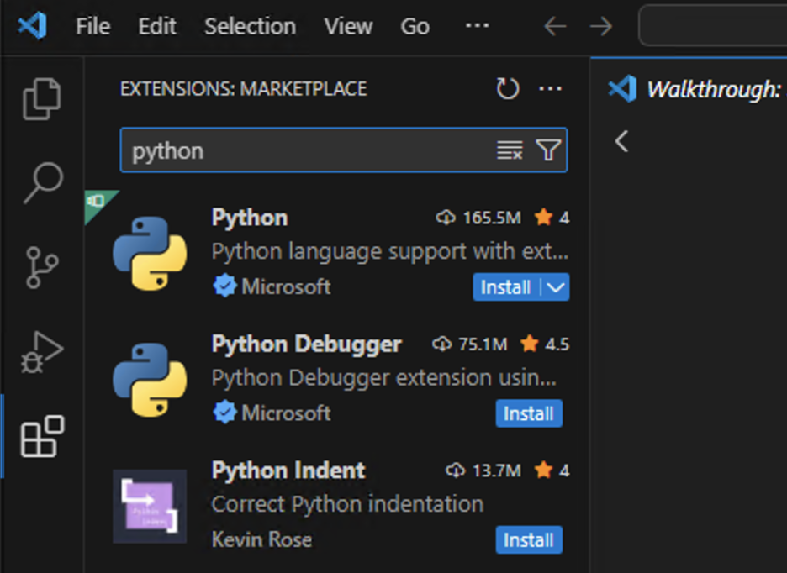

4. (Windows user) Install Remote Development

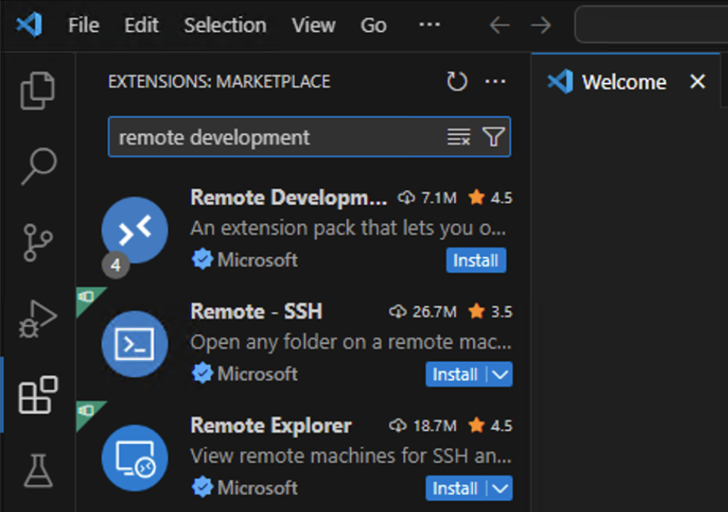

4. (Windows user) Connect to WSL

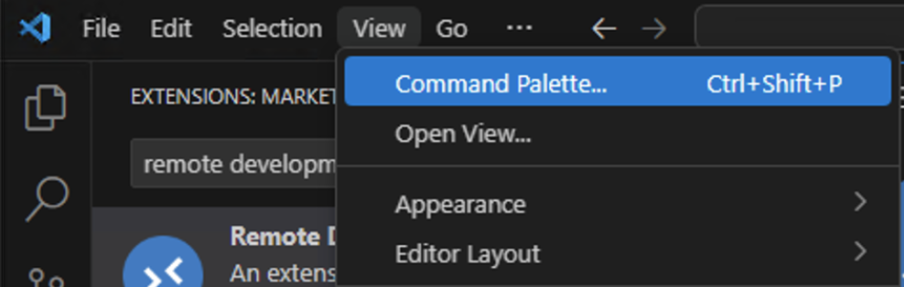

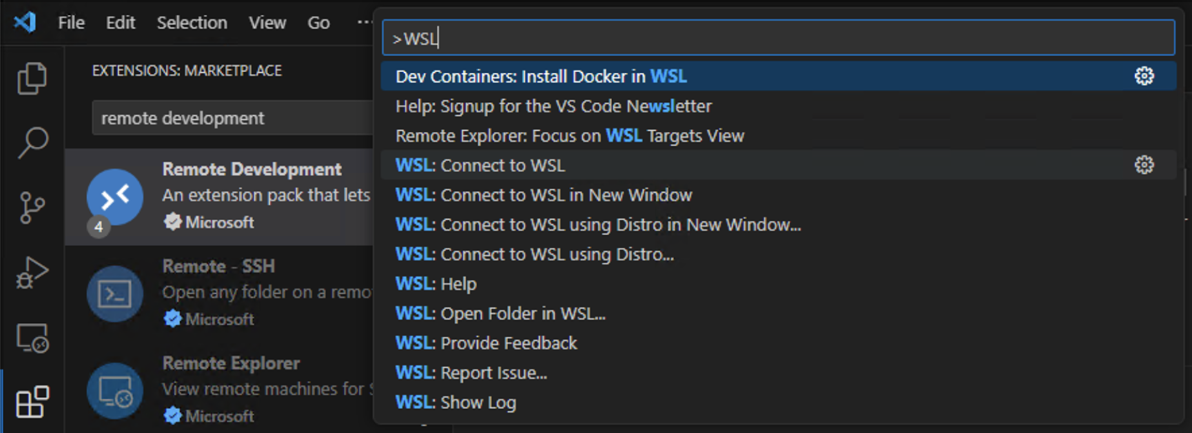

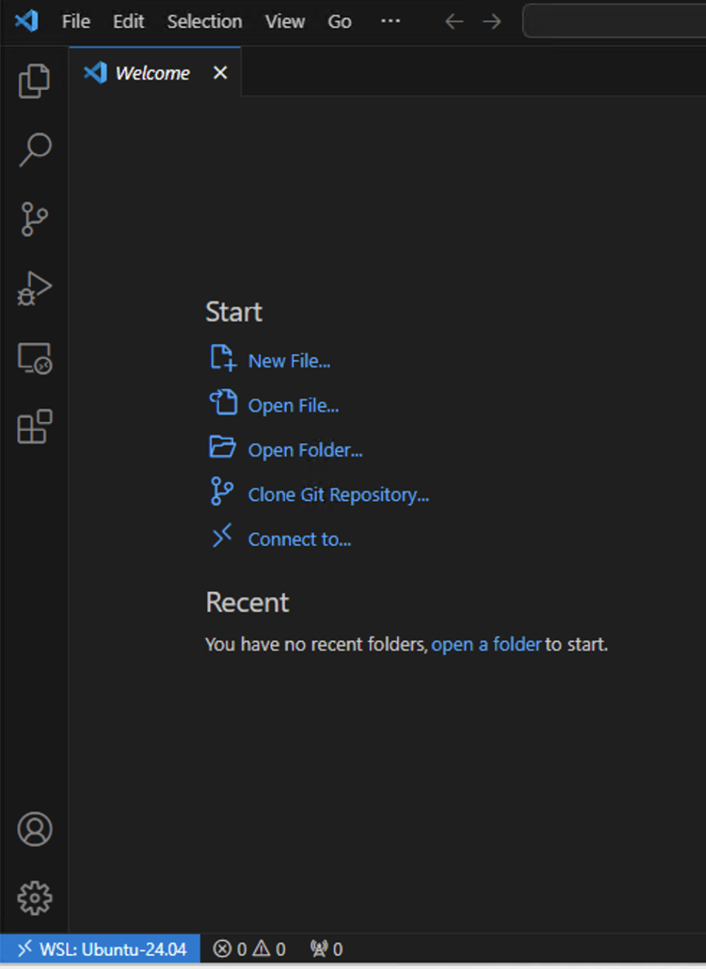

5. (Mac/Linux user) Connect to Python Directly

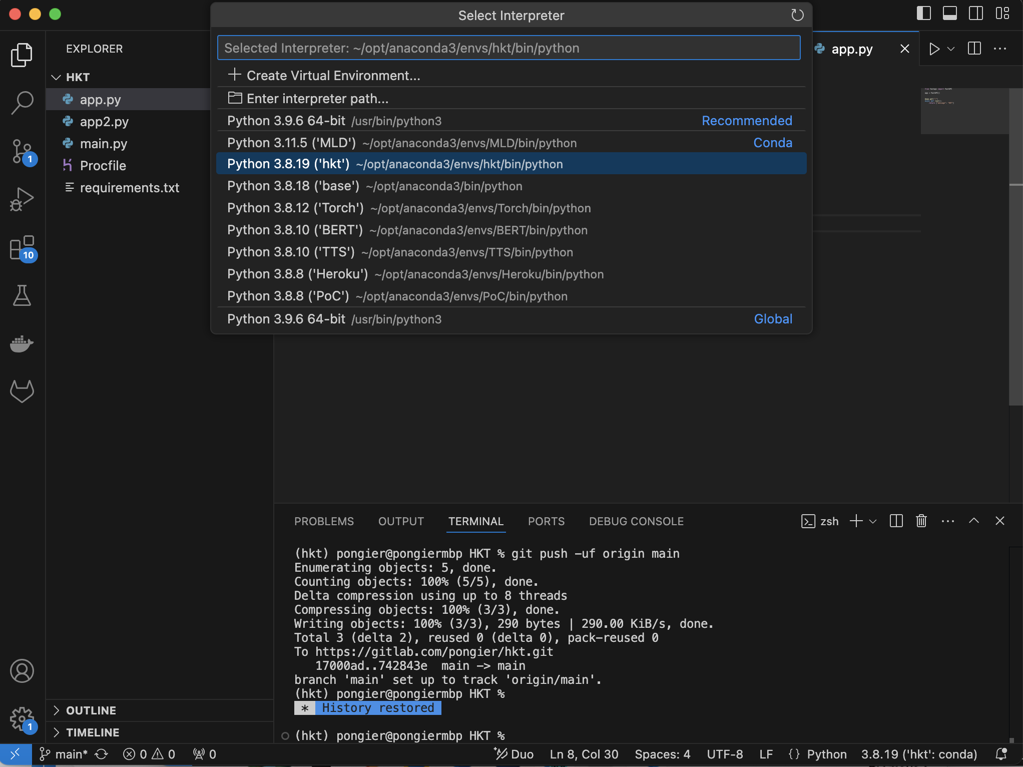

**(All user)**

**How to install Postman (API Testing)**

1. (All user) Download and Install

* <https://www.postman.com/downloads/>

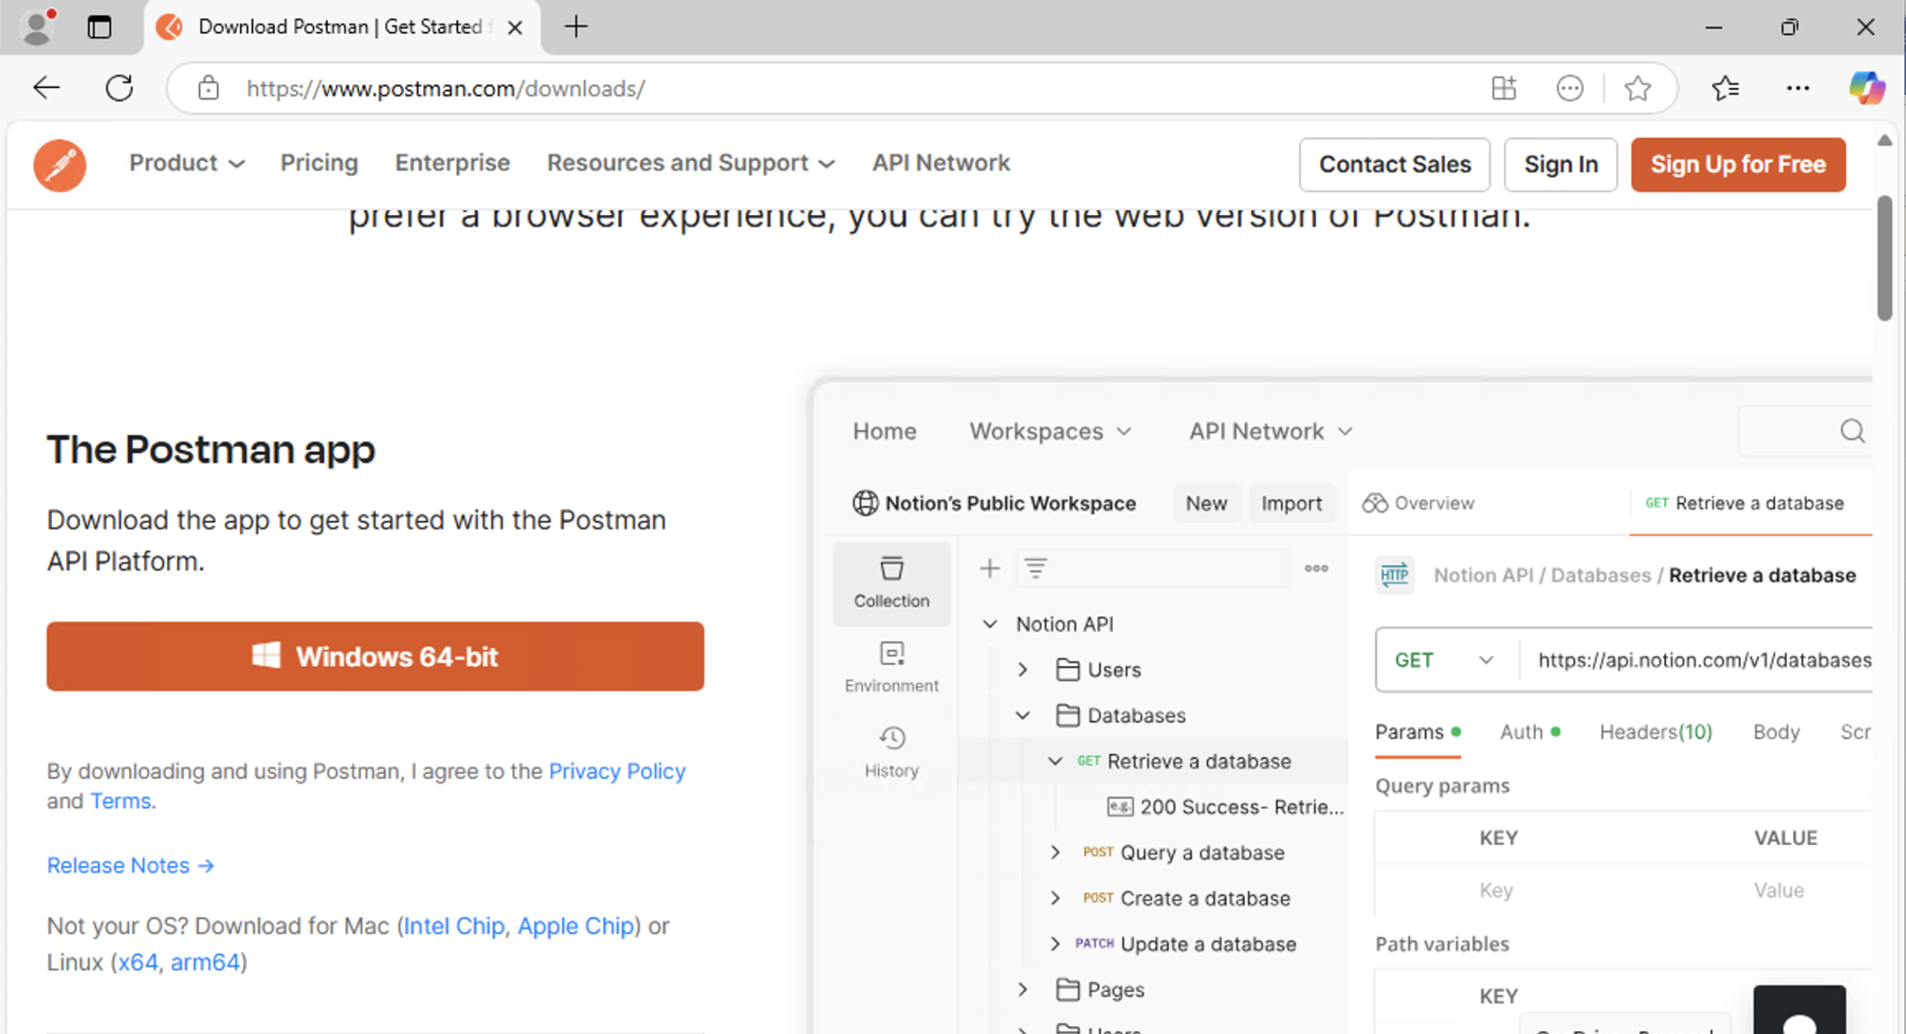

2. (All user) Install and Launch Postman

